MVC Web App solution to consume a Web API

Download the source code – Developed in MVC 5 – Dotnet Framework 4.5 – Vs.net 2013

Open it in visual studio and Press F5 to build and run the Web Application

If you intend to change the input parameters to the API do change the hardcoded values (refer circled values in orange)

Screenshot 1: Source code at a glance

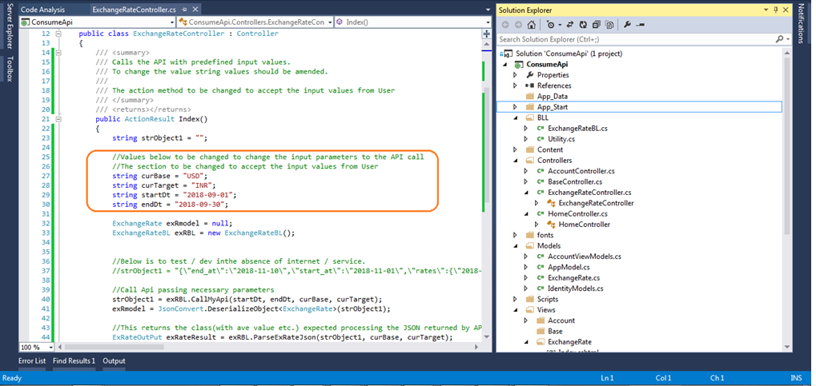

Screenshot 2: You will see below screen on successful compilation (Pressing F5) from Visual Studio

Click on ExchangeRate button (circled in blue) to see the screenshot 3:

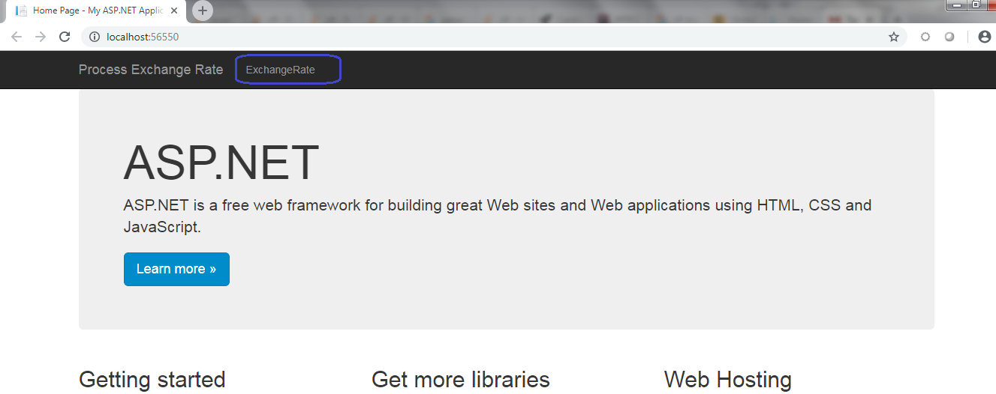

Screenshot 3: You see below screen on click of ExchangeRate button/menu option

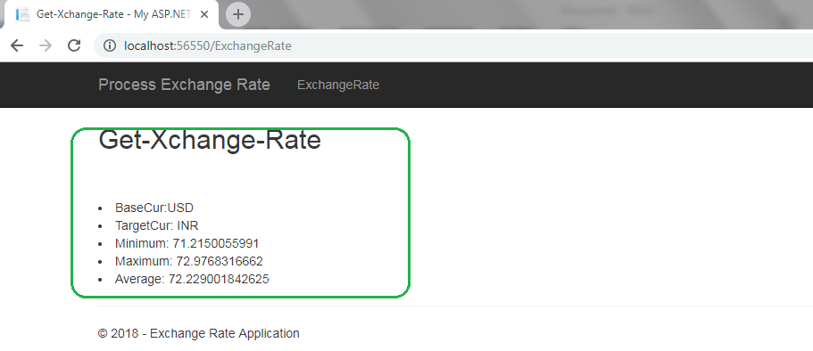

Note –

This solution should be further improved to capture the input parameters for the API. Subsequently Rest of the code are dynamically written to account the change in input parameters processing the necessary output.

Exception handling and logging could be implemented and improved.